23.44: a)
(i) 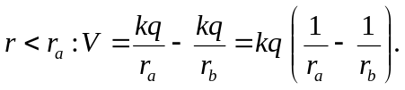
(ii) 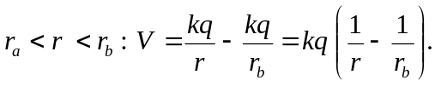
(iii) 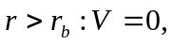 since outside a sphere the potential is the same as for point charge. Therefore we have the identical potential to two oppositely charged point charges at the same location. These potentials cancel.

b) 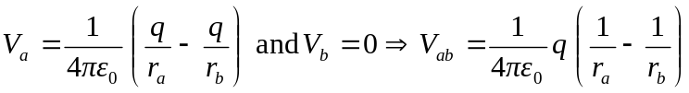

c) 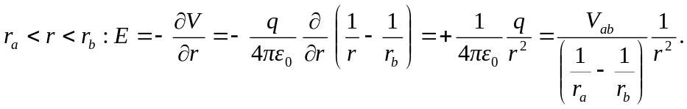
d) From Equation (24.23): 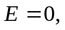 since is zero outside the spheres.
e) If the outer charge is different, then outside the outer sphere the potential is no longer zero but is 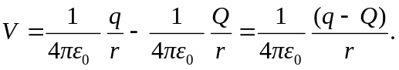 All potentials inside the outer shell are just shifted by an amount 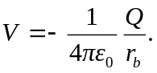 Therefore relative potentials within the shells are not affected. Thus (b) and (c) do not change. However, now that the potential does vary outside the spheres, there is an electric field there:
